**Buddies for the Zambia virtual study tour**

During the virtual study tour each delegate will have a Zambian buddy (partner/ mentor). The buddies are either Principal Trainers or Observers in Zambia (don’t worry if you don’t know what these jobs are, you will learn more about them soon!).

The buddies are all familiar with the inclusive education teacher training programme. Your allocated buddy will be available to answer your questions and discuss ideas during the virtual study tour, and they want to learn from your experiences too.

During the current Covid-19 crisis, some buddies may find it more challenging to get internet access. Please be patient if there are some communication delays. If you have an ongoing problem with contacting your buddy, you can email [vst@eenet.org.uk](mailto:vst@eenet.org.uk) and ask for support.

## Introducing the buddies

This document provides some details about the buddies, their regular jobs, their specific roles in the teacher training programme, and their reflections on the programme. You may find it useful to keep this document for reference throughout the tour, so you can revisit the buddies’ profiles as you become more familiar with how the programme works, and what everyone’s role is.

Introducing the buddies 1

Buddies – Principal Trainers in Zambia 2

Aubrey Moono 2

Audrey Sibamba Malumo 4

Bridget Mukwiza 6

Cotildah Hamalengwa 7

Eunice Simonde Siachobe 8

Jonathan Kasolo 10

Lillian Chipatu 11

Nachiyunde Kabunga 12

Olive Samukolo 13

Orgency Malumbe 14

Patrick Kaluba 15

Presley Mulenga 16

Silvia Mulenga 17

Wesley Mweemba 18

Yvonne Malambo Kabombwe 19

Buddies – Observers in Zambia 20

Caleb Callan Chabiauni 20

Lillian Haangoma 21

Musola Kaseketi 22

Samson D Sakala 23

Sharon Handongwe 24

Tom Lwendo Mungala 25

Winniefreda (‘Winnie’) Moonga Bbwantu 26

# 

# Buddies – Principal Trainers in Zambia

## Aubrey Moono

**Head of Section (Expressive Arts Education) and Senior Lecturer at Charles Lwanga College of Education in Monze, Southern Province.**

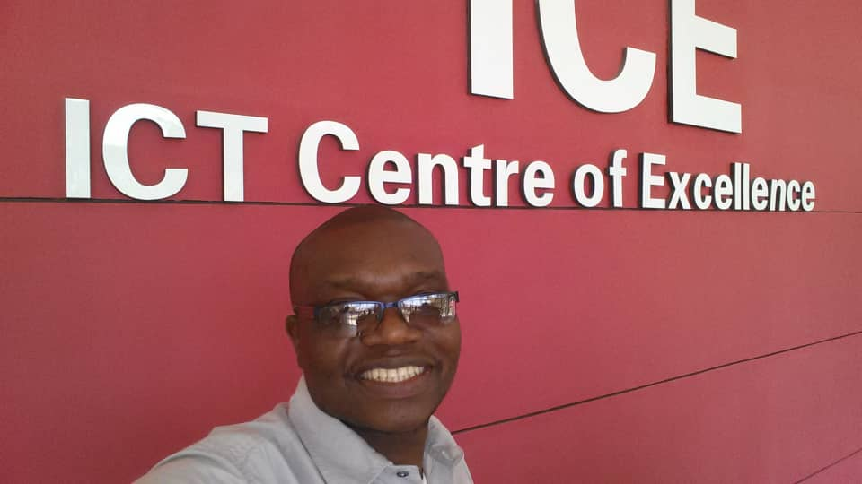

**My roles include**

* Heading Expressive Arts Education Section;
* Lecturing/teaching/training student teachers;
* Section/individual work planning;
* Researching, supervising research students
* Principal training for ICT and inclusive education.

**What I have learned from the inclusive education programme**

* Inclusion is about all children and not just children with disabilities.
* Children learn differently and so different learning styles must be employed at all times.
* Learning is participatory; so teaching must be participatory too, thus learner–centred.
* Materials do not always have to be bought but often can be locally made from the waste materials, thus helping to clean up the environment too!
* That an Individual Education Plan (IEP) is created for a particular child and not for all children at a time; meaning challenges of one child may not be generalised to all the children in the classroom.

**What is the impact of the inclusive education programme on my work as a lecturer?**

* I have learned to include all my students, beginning at the planning stage.
* I have changed my teaching style; less passive lecturing and more group activities and projects.
* It has made me understand the individual differences in my students in terms of their learning styles – students learn differently.
* I have learned to incorporate my students in my lessons even when teaching with ICT, e.g. those learners with visual impairments now have their ICT work accompanied by sound, and if they are working from the board they can sit in front of the class; those learners with hearing impairments now have their work accompanied by pictures and videos, etc.

**What I enjoy most about principle trainer in NAD-Zambia’s inclusive education programme?**

* When inclusive strategies are being applied by the teachers in pilot schools and/or by student teachers when in teaching practice (i.e. including all learners in their planning and lessons).
* When the trainee students or teachers I train realise that learning is usually about their individual needs, and not about a group’s needs.
* When I see teachers using local materials to make learning and teaching aids.
* When teachers are able to identify barriers and offer solutions to the identified barriers.

## Audrey Sibamba Malumo

**Officer working for Ministry of General Education (MoGE) as a District Resource Centre Coordinator (DRCC).**

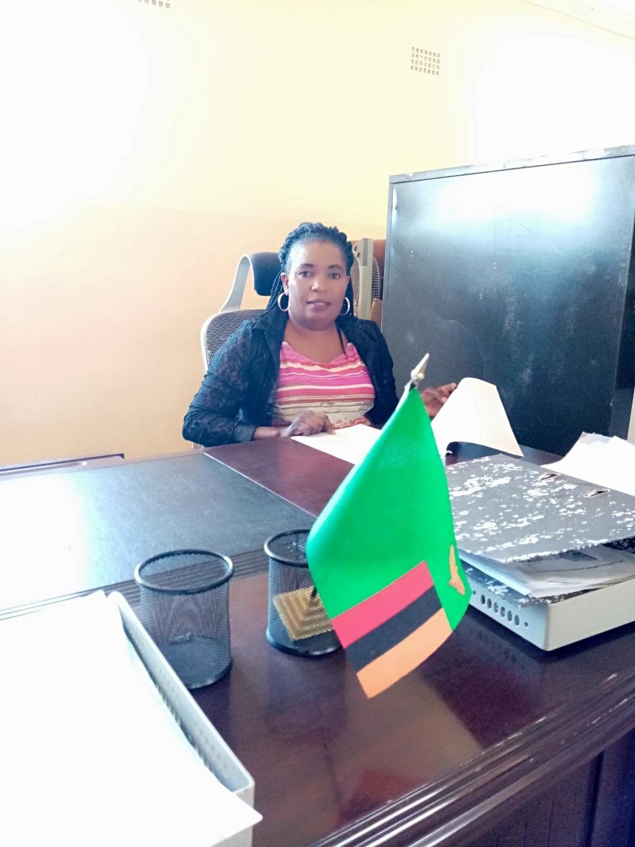

I have been a teacher for 22 years. For the last seven years I have been an assistant DRCC in Kazungula District and I am now the DRCC for Zimba District. My main job is to coordinate and administer the District Resource Centre (DRC), as well as facilitate in-service training programmes in order to improve the professional teaching performance of the teacher.

**My roles as DRCC include:**

* To effectively manage and administer the DRC in order to ensure smooth running of the centre.
* To effectively coordinate and facilitate District and Zonal in-service training programmes in order to improve the quality of teaching and learning.
* To monitor and evaluate effectively and regularly the District and Zonal in-service programmes in order to identify new training needs.
* To promote educational policies, initiatives and programmes in the district.
* To promote partnerships with other educational institutions, government agencies and other key stakeholders such as Community-Based Rehabilitation/Community-Based Inclusive Development (CBR/CBID).

I have an excellent knowledge of inclusive education at school level because I worked as the School Inclusive Education Coordinator (IECo) at Riverview School, Kazungula District, before being appointed as DRCC in Zimba District. Currently, I am a Principal Trainer for the inclusive education teacher training programme. I am working closely with Luyaba and Nakowa pilot schools in my District and I sensitise other schools which are not yet implementing this programme.

In most parts of our communities countrywide, learners who are differently abled are marginalised and denied a chance of being educated. These children in most cases are hidden from society and are negatively labelled. The inclusive education training of trainers workshops I have attended, as well as the in-service training I delivered in the pilot schools, has taught me not to perceive these excluded children differently, but see them as regular human beings who need support and love.

As a Principal Trainer, the Inclusive Education Programme has increased my knowledge and skills on how to include children with special educational needs. I have endeavoured to equip teachers with knowledge and skills of screening learners with special educational needs, to build teachers’ capacity on appropriate assessments and conducting continuous assessment. I empower teachers with multi-level instructional approaches and increased attention to diverse learners’ needs and individualism. It is my role to raise awareness in the community and to encourage them to bring all their children to school. Marginalised children now have the opportunity to learn together with their peers. The Inclusive Education Programme has changed the mindset of teachers, parents and learners.

As DRCC, my goal is to improve teachers’ performance by ensuring that they engage in reflective practice, deepen their knowledge, and extend their professional skills. Teachers need to keep themselves up-to-date with major developments affecting their profession in order to accommodate all learners, as noted by Zambia’s Curriculum Framework, page 21, and Sustainable Development Goal (SDG) 4, which aims to “Ensure Inclusive quality education and promote lifelong learning opportunities for all”.

As DRCC and a Principal Trainer, I feel honoured and proud to carry the flag of inclusive education in the MoGE. The extensive training experience on inclusive education, coupled with my job experiences, have made me ready to help learners, teachers, parents and other stakeholders on the importance of inclusive education. The most exciting thing is to see learners being part of their communities and develop a sense of belonging and become better prepared for life in their community as informed adults.

## Bridget Mukwiza

**Deputy head teacher at Shampande Primary and Secondary School in Choma, Zambia.**

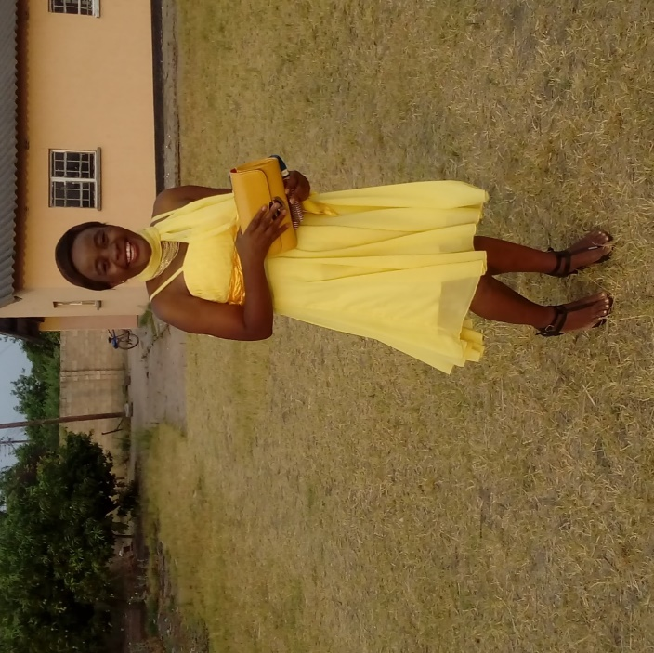I have been in the teaching fraternity for 18 years. My role as deputy head teacher is to coordinate the development and implementation of administrative and academic programmes in order to facilitate the development of quality education.

Before the appointment as deputy headteacher, I worked as District Resource Centre Coordinator (DRCC) for Zimba District where my role was to coordinate the District Resource Centre, as well as facilitate in-service training programmes in order to improve the professional performance of Zimba District teachers. Being in the pilot district of NAD-Zambia’s inclusive education teacher training programme, I was privileged to become a member of the training of trainers group, Principal Trainers, trained in inclusive education teaching and learning methodology by EENET and NAD-Zambia from 2016 to 2019.

As a DRCC, I interacted with different people including teachers, education standards officers (ESOs), civic leaders, parents and many others. I always share my knowledge of inclusive education with others. In my current position, I use the knowledge to teach and monitor teaching and learning activities that may or may not promote inclusive learning, and I offer advice to ensure solutions are found to any challenges that appear.

I enjoy sharing the knowledge I have about inclusive education, emphasising the need to ensure all children are present, participate and achieve in their academics and in life at large.

## Cotildah Hamalengwa

**Senior lecturer at Charles Lwanga College of Education, Monze, Southern Province.**

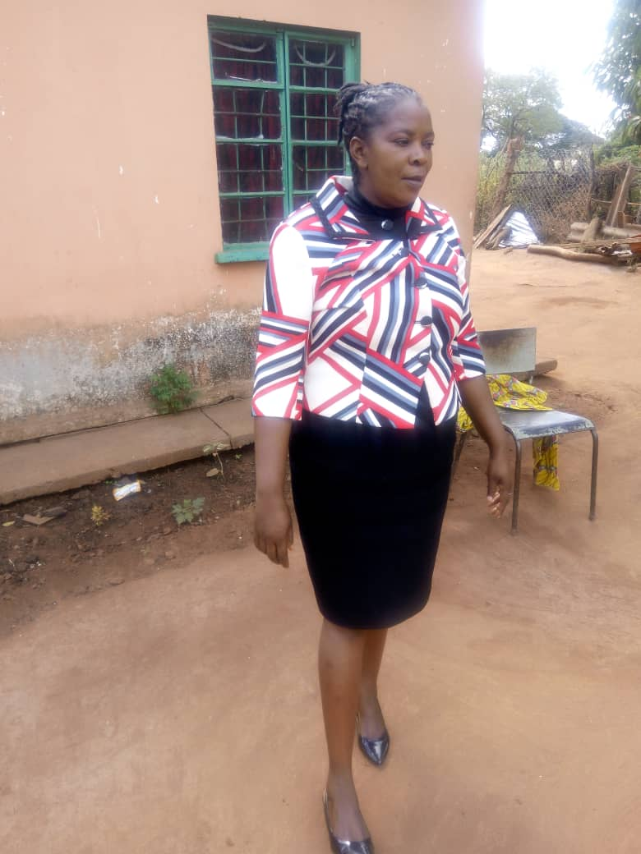

I teach Theories and Practices of Education (methodology) and also Education Management and Administration. I feels it is my responsibility to train student teachers so that they can become excellent qualified teachers after completion of their course of study.

I also train in-service teachers on NAD Zambia’s Inclusive Education Programme. Being a Principal Trainer in inclusive education, I have learned that inclusive education is not only about learners with disabilities, but about all children – no matter who they are, and they can all learn together in the same school. That means reaching out to all learners, especially those who are out-of-school, and removing the barriers that could limit their presence, participation and achievement.

I am content knowing that children learn differently and seeing teachers and student teachers prepare specially designed instructions and support that can help all children to make progress and achieve in all aspects of life.

## Eunice Simonde Siachobe

**Head teacher, Luyaba inclusive school in rural Zimba District, Southern Province.**

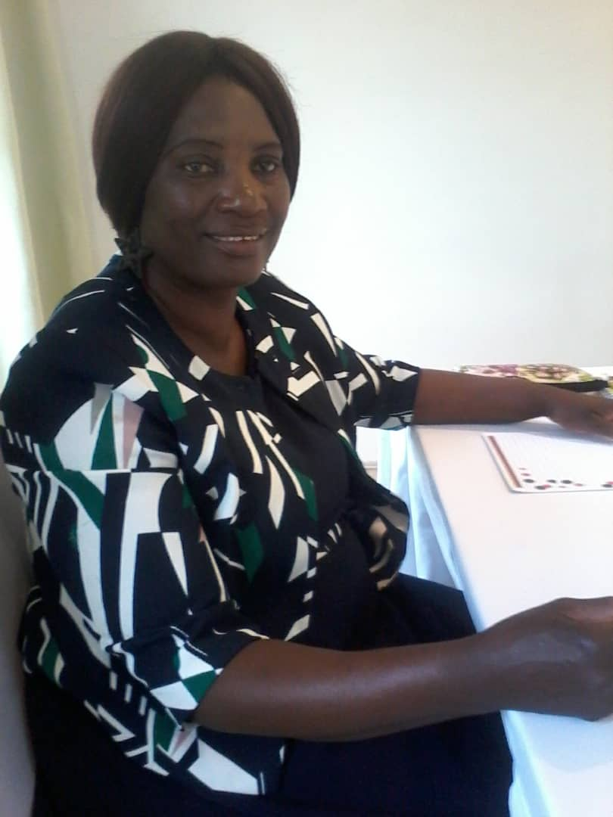Luyaba is a pilot school in NAD-Zambia’s Inclusive Education Programme. I am a Principal Trainer in the programme.

**My inclusive education roles**

1. Raise awareness about inclusive education with teachers, learners, and the community (parents-teachers association (PTA), school board members, the school inclusion team (SIT), the chief, headmen, etc).
2. Train teachers about inclusive education pedagogies and monitor all the inclusive education activities in the school.
3. Collaborate / network with other organisations to enhance education for all.
4. Work with the school inclusive education coordinator (IECo) to identify inclusion challenges / barriers through action research, and then design interventions with the teachers and SIT members to ensure all learners are present, participating and achieving.)
5. Bring back to school those who have dropped out due to: pregnancy, disability, vulnerability, illness, and orphans. Bring into school those who have never attended.
6. Conduct some home visits, educate parents on home-based care for learners with severe disabilities, monitor physiotherapy activities taking place in the school and giving advice where necessary.
7. Make sure teachers’ attitudes are positive, the environment is conducive for all, the community is supportive, and resources are available, so as to enhance quality education for all.

**What have I learned from the training of trainers workshops for Principal Trainers, and how does this help with my work?**

1. Awareness-raising is cardinal when embarking on any new activity, this helps people give their full support.
2. Identifying barriers in a local area or locality enables one to come up with working interventions that belong to the school and community.
3. Involving all stakeholders with new ideas is very important, this enables a school to achieve an intended goal.
4. Varying teaching methodologies, using participative methodologies, helps all learners achieve their goals.
5. Learners should be present in class, participate fully, and this is the best way they can achieve. Head teachers should monitor this to ensure all learners receive good results.
6. A head teacher’s time management is very important. Not spending time on things that distract his/her attention when doing something important, thus enabling them to receive every bit of information. E.g. too much use of phones.
7. Involving all stakeholders in decision-making, including learners, creates a positive school environment.
8. Newcomers should be welcomed; their performance tracked and induct them to feel welcome and to achieve in the school.
9. Knowing the learners’ background is very important; you will know where to place them in class, and be able to offer them appropriate guidance to help them to achieve.

The inclusive education programme has helped me acquire new skills so that I am able to train anyone about inclusive education. As a head teacher it has made monitoring easy, e.g., when checking Individual Education Plans (IEPs) of learners with disabilities.

All in all, the training has helped me become a more competent head teacher, entrusted with all the skills to handle most of the situations in the school. As a head teacher I hold keys to every child’s success.

## Jonathan Kasolo

**Teacher and currently the assistant District Resource Centre Coordinator (DRCC) for Livingstone District**.

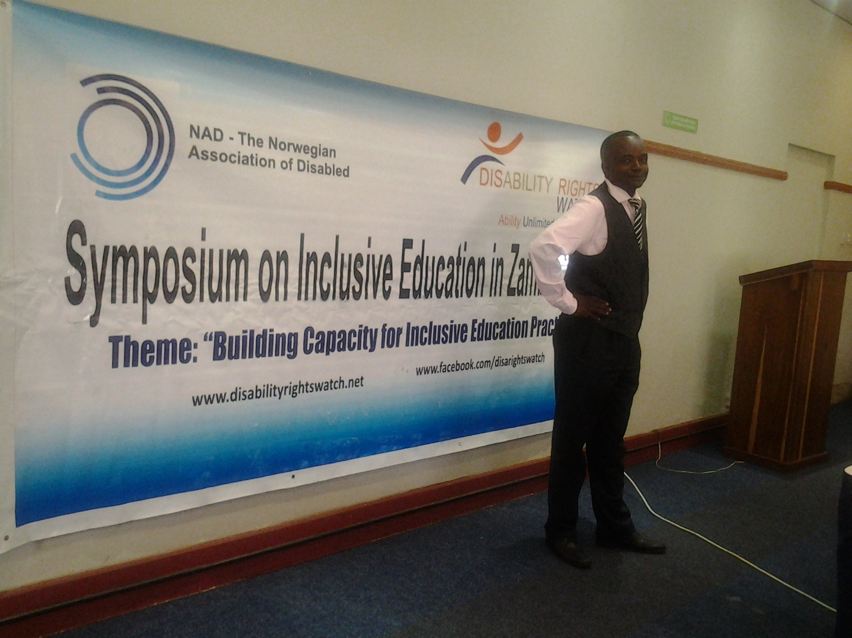Initially, I trained as a primary school teacher and began teaching in 2002. In 2012, I was appointed to coordinate one the six zones in Livingstone District. Later, in 2014, I was given the responsibility of coordinating Livingstone District as an assistant DRCC.

**My roles include:**

* Coordinate the continuing professional development (CPD) of all the district’s teachers to enhance quality education in the district.
* Supervise the implementation of the CPD programme in the district’s zones.
* Monitor the government’s recommended strategies and approaches of teaching.
* Identify teachers’ pedagogical needs and provide appropriate support through the identification of the resource persons needed to train them in the identified areas.
* Link the District Education Board (DEB) office to the district’s zones.
* Link the district’s CPD with the province’s CPD.
* Oversee all the CPD at school and zonal levels.

The Inclusive Education Programme has helped me assist marginalised people in society.

**What I have learned includes:**

* Reflection on the key issues of learning.
* Collaborating with other relevant government departments.
* Planning.
* Networking with key stakeholders such as civic leaders, traditional leaders, school administrators, teachers and many others.
* Some practices which hinder the academic development of learners.
* Identifying learners’ individual learning barriers to learning among children.
* Overcoming barriers through collaboration with others.

**What I enjoy most about my job:**

* Working with other people in implementing inclusive education in the pilot schools.
* Presenting the content of the trainings in interactive strategies such as group discussions and hands-on activities with the pilot schools’ teachers.
* Being positively criticised when I felt I was right, yet I was wrong.

## Lillian Chipatu

**Lecturer in the School of Education at the University of Zambia (UNZA), Lusaka.**

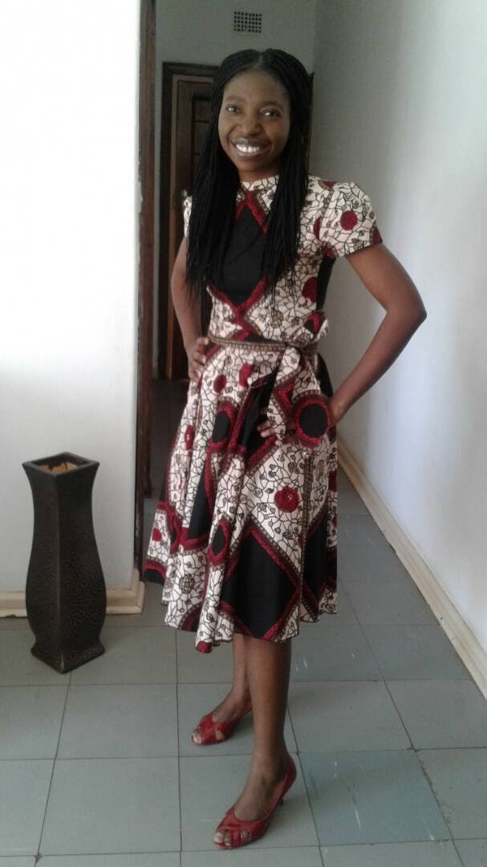

I lecture, teaching methodology (in the Geography and Environmental Education Department) and educational research. I joined UNZA eight years ago and have been involved in teacher education, community service, research and publication. This has helped me interact and exchange ideas with student teachers, community and the academia at large.

I had the opportunity of being trained in inclusive education by the NAD-Zambia programme. The knowledge acquired during the inclusive education training of trainers workshops has been helpful in my job as a teacher trainer; particularly in helping student teachers understand the techniques, approaches and methods that are inclusive in teaching. Furthermore, I have had an opportunity to share and exchange ideas on inclusive education within and outside the university.

## Misley Mungala

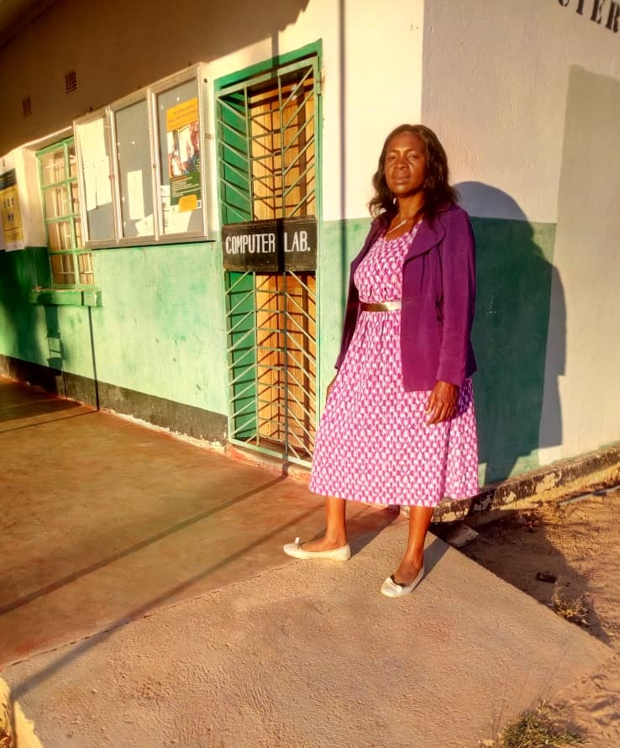Head teacher of Nakowa Primary and Secondary Inclusive School, Zimba District, one of the six pilot schools taking part in the inclusive education programme.

I started working as a primary school teacher in 1993 and later gained a diploma in secondary school teacher education. I have had several roles as head of department, deputy head teacher, acting head teacher and finally as head teacher.

I learned a lot about inclusive education during NAD-Zambia’s programme and some of my new roles include:

* to train teachers on inclusive education in the pilot schools and monitor all the inclusive education activities in her school;
* to raise awareness about inclusive education in the community;
* to collaborate with the School Inclusion Team (SIT), the Parent-Teacher Association (PTA), the school inclusive education coordinator (IECo), the community and the Headmen;
* to network with stakeholders such as the community and the school IECo in identifying barriers to learning in the school through action research;
* to collaborate with the SIT members and the school IECo to devise interventions that will help include all learners;
* to work with the SIT members and the school IECo to identify out-of-school children and bring them back to school.

The inclusive education training has helped me to:

* collaborate with key stakeholders such as traditional leaders, NGOs, teachers, learners, etc;
* understand that learners have different educational needs and hence some of them need an Individual Education Plan (IEP);
* overcome barriers through collaboration with key stakeholders;
* understand that all learners can learn, regardless of their challenges, when differentiated learning is applied;
* create teaching and learning aids using locally available materials without any cost;
* understand that for a learner to perform well in class, she/he needs to be Present, Participate and Achieve (PPA);
* understand that interactive learning helps all learners to achieve.

Finally, I have enjoyed working with other people during the in-service training I have delivered, therefore implementing inclusive education in pilot schools. From the inclusive education training workshops I acquired new skills to help include learners with different needs, including learners with disabilities.

## Nachiyunde Kabunga

**Science education lecturer in the School of Education at the University of Zambia (UNZA), Lusaka.**

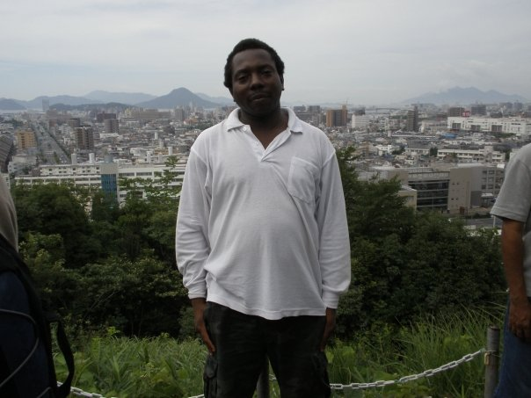

I first worked as a secondary school teacher from 2001 up to mid-2008. I taught physics and chemistry at Arakan Secondary School. From mid-2008 to date, I have served UNZA in various positions, and the most recent being as an educator of science education.

I have had extensive experience in mentoring mathematics and science (physics, chemistry, agriculture science and biology major) students. I mentor mostly science education students at undergraduate, and at postgraduate level I mentor both mathematics and science students. I am also, occasionally, called upon to grade research proposals from all manner of students at postgraduate level. Some of students I handle include those majoring in special education, psychology and sociology.

My level of mentorship was greatly enriched when I was given a rare opportunity to participate in NAD-Zambia’s Inclusive Education Programme’s training of trainers workshops, under their Community-Based Rehabilitation (CBR)/ Community-Based Inclusive Development (CBID) work in Zambia.

The new skills I gained have enhanced the way I handle classes, both undergraduate and postgraduate. The deeper understanding of inclusive education has benefited the past generation of students and is yet to benefit future generation of students. The students at UNZA are required to go out for a practicum (teaching practice). One of my major tasks is to visit student teachers on attachment in various schools across the country. It is clear that some of my efforts in using inclusive education methodology in my lectures are beginning to yield rewards, judging from some of the lessons I have observed. Some elements of inclusive education are slowing gaining ground as evidenced by the way some of the students were delivering their lessons.

I am forever searching for new ways of teaching and learning. I enjoy inspiring my students to find new ways of engaging their learners, especially during their peer-teaching sessions and duplicating these skills when they teach learners in a school setting. I always encourage my students to focus on what is locally available and to make good use of it. I am passionate about developing novel ways to teach using ICT tools and locally available and traditional materials. I am always on the lookout for tools and methods that can make my teaching continuously improve. I also repackage traditional methods of teaching subtly to have a lasting appeal on local students. The modules covered during the training of trainers workshops have been invaluable in this pursuit of excellence in teacher training and lesson delivery.

## Olive Samukolo

**Lecturer at Victoria Falls University in Livingstone.**

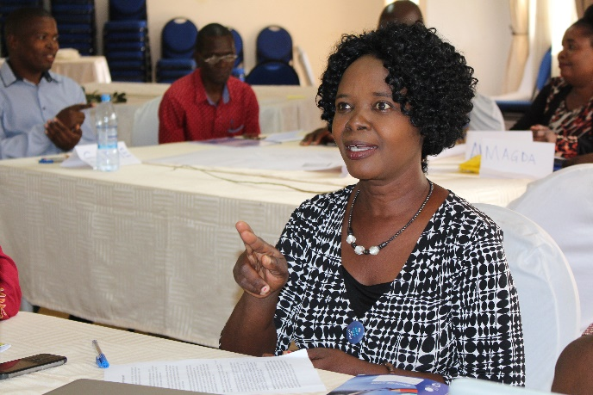

I am the current acting dean of students and a Principal Trainer in NAD-Zambia’s Inclusive Education teacher training programme.

My role at the university is mainly to train trainee teachers; to deliver teaching skills, knowledge and values to the students and to help run the affairs of the university.

What I have learned from the Inclusive Education Programme is the importance of bringing everyone on board and not leaving anyone behind. Being part of the programme has helped me increase the presence, participation and achievement of all my students at the university. The university now works towards education for ALL.

Education is an aspirational process, therefore I enjoy learning what I am taught by the facilitators and also from my colleagues. Furthermore, I love to keep improving as a PT, I enjoy teaching and training both pre-service students and in-service teachers, facilitating success and changing lives.

## Orgency Malumbe

**Head teacher, Shungu Pre, Primary and Secondary School in Livingstone District.**

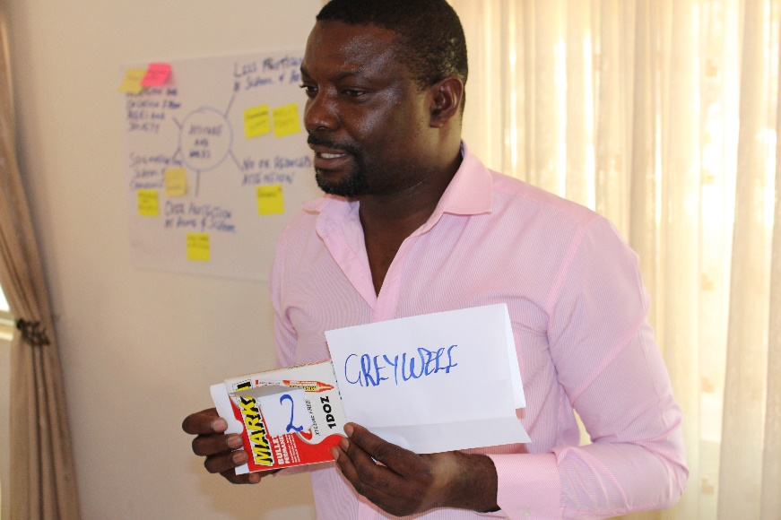Shungu is a pilot school in NAD-Zambia’s Inclusive Education Programme. This school is a Zonal centre, leading a number of neighbouring schools in the zone.

I oversee administrative and academic management of the school and of the zone, and am a Principal Trainer. I deliver inclusive education in-service training in other pilot schools within the Inclusive Education Programme, e.g., Luyaba school, but not in my own school.

I have learned tolerance, engagement, patience, reciprocity, team work, sustenance and the importance of focusing on participatory activity and role-play. I have enjoyed the high levels of interaction, the exchange of ideas among trainers and the responses from teachers and learners.

I now have a wider knowledge base about inclusion, as opposed to mere special education. These are several things in what has been an interesting experience for me throughout the process.

## Patrick Kaluba

**Education Standards Officer (ESO) – General Inspections, at Gwembe District Education Board (DEB) Office, Southern Zambia.**

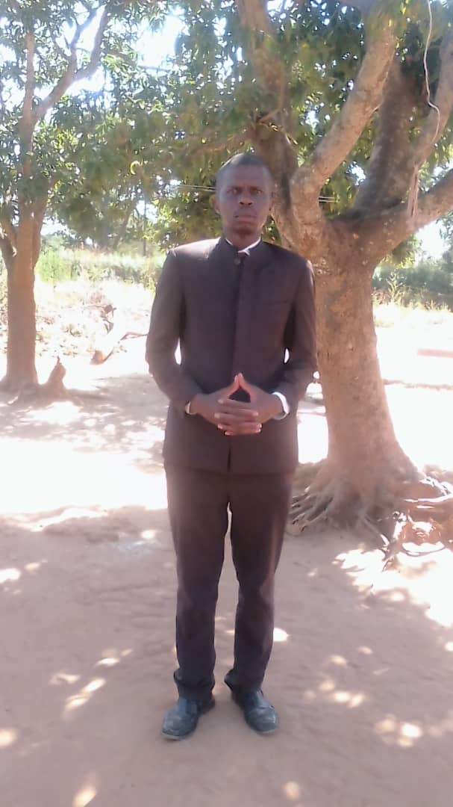

I have worked for the Ministry of General Education (MoGE) for 24 years. I was a teacher and, in 2015, became an ESO – Special and Inclusive Education for Zimba District, one of the inclusive education programme’s pilot districts. I then transferred to the neighbouring Gwembe District.

My key role as an ESO is to ensure that institutions of learning (schools and colleges) strictly comply with the set standards with a view to attaining quality, equitable and inclusive education throughout Early Childhood Education, Primary, Secondary and Tertiary Education. Furthermore, I monitor and inspect schools and colleges to ensure that teaching and learning are of the highest quality, i.e., content, teaching and learning methodology (pedagogy), instructional materials and a conducive learning environment.

I am one of the Principal Trainers in NAD-Zambia’s Inclusive Education programme. I share the acquired knowledge, skills and experience with school managers (administrators), practising teachers, and education personnel at district offices. My passion has been giving advice to practising teachers and school administrators on practical strategies on overcoming policy, practice and resource barriers or challenges. I have always seized every opportunity that presents itself during interactions with school administrators and practising teachers to share information on inclusive education.

As an ESO, I enjoy seeing that all education players at school and college levels improve access (presence) to education for ALL learners, that participatory methodologies are developed and that all learners achieve in curricular and extra-curricular activities to the best of their abilities.

## Presley Mulenga

**Head Teacher for Riverview Primary and Secondary Inclusive School in Kazungula District.**

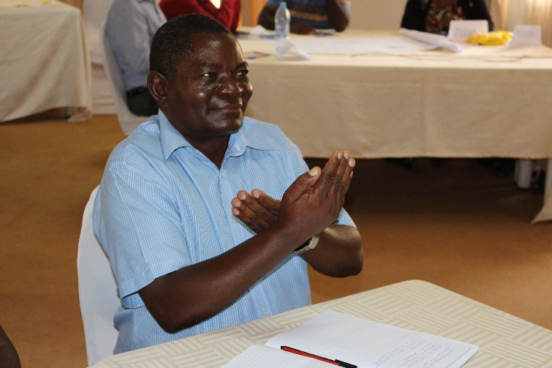

I am a Principal Trainer in CBR Zambia support programme under inclusive education and also a Reverend.

As a head teacher I am responsible to lead, motivate and manage staff by delegating responsibility, setting expectations and targets and evaluating staff performance against them. I have a strong presence around the school and the local community

As a Principal Trainer I have learned the importance of preparation. One of the interesting things for me is to be part of a team that is dedicated to promoting inclusive education. As a Principal Trainer I ensure that all the training materials are ready. It also means that I have to put in a little extra effort to make sure that the teachers to be trained are ready and available to learn.

Inclusive education has improved my overall leadership and management of the Riverview school. The school is located in a border town and as such comes with a lot of challenges which I have managed to address in collaboration with the SIT, the community and all involved stakeholders.

What I love the most about my work is that I am able to accomplish my vision, inspiration, and initiative to complement the policy guidelines on education in Zambia. I have the community development agenda which must include all learners.

## Silvia Mulenga

**Teacher and District Resource Centre Coordinator (DRCC) for Kazungula District Education Board (DEB).**

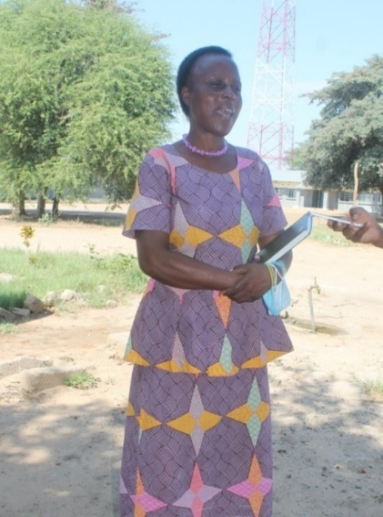

As DRCC, my main role is the in-service training of teachers. This continuing professional development (CPD) includes monitoring; needs identification, and the creation of teaching and learning aids from locally available resources.

I am a Principal Trainer for inclusive education and I have learned that everyone has a right to access education. Inclusive education has opened my mind and has cleared all my fears and doubts that learners with disabilities could not learn with others. I initially thought that learners with disabilities would be a disturbance in class, and disturb the regular learners. I used to segregate them but I changed my mind-set and my teaching methodology with the introduction of the Inclusive Education Programme. I now encourage parents to send children with disabilities to schools.

I enjoy training and coordinating all teachers in my district in an inclusive way.

## Wesley Mweemba

**District Resource Centre Coordinator (DRCC) for Livingstone District Education Board (DEB).**

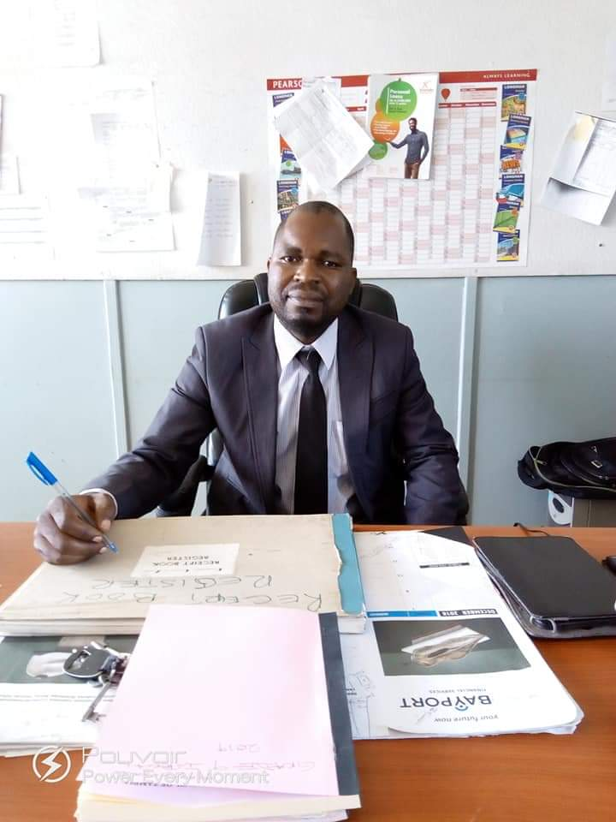

Before my appointment as DRCC, I worked as a Zonal in-service training (INSET) Coordinator (ZIC) in Monze Town Central Zone, as well as Assistant DRCC (Ass/DRCC) for Monze District. As Ass/DRCC my role was to coordinate the zonal INSET activities and assist in the running of the DRC, as well as facilitating INSET programmes in order to improve the professional performance of Monze Town Central Zone teachers and Zimba District teachers as a whole.

Being in the pilot district of NAD-Zambia’s inclusive education teacher training programme, I was privileged to become a member of the trainer of trainers group, the Principal Trainers who were trained in inclusive education teaching and learning methodology by EENET and NAD-Zambia from 2016 to 2019.

Being the Livingstone DRCC, I interact with different types of people including teachers, education standards officers (ESOs), civic leaders, parents, etc. I always shares my knowledge of inclusive education with them. In my current position, I use the knowledge to train, sensitise, guide and monitor teaching and learning activities. I encourage teachers to use inclusive education methods as they teach learners in their classrooms, and consider inclusive approaches during lesson planning and delivery.

I believe that all children need to be present in school, and participate and achieve in the learning process, and that teaching approaches and methods should always be learner-centred, where learners take the centre stage in the learning process.

**Benefits of inclusive education to the DRCC**

* Before I was involved in the inclusive education training I did not understand the difference between inclusive education and special education. But now I do. Inclusive education is a broader concept, involving all learners, of which special education is just one part.
* I understand that all learners need to be present, participate, and achieve in the learning process regardless of their status, while special education targets only specific children with specific disabilities or learning disabilities. These are also considered in the inclusion process.
* My knowledge and understanding of inclusive education helps me in my day-to-day duties as a teacher, educator and a coordinator of INSET.
* As a Principal Trainer I am now better placed to train other stakeholders and teachers in inclusive education methods and implementation in the district.
* I understand that the schools need to have the School inclusion team (SIT) and school inclusive education coordinator (IECo) who should spearhead inclusive education programmes in the school, in collaboration with the school administration and the community.

## Yvonne Malambo Kabombwe

**Lecturer and researcher in the School of Education’s Department of Language and Social Science Education (History Education Section) at the University of Zambia (UNZA), Lusaka.**

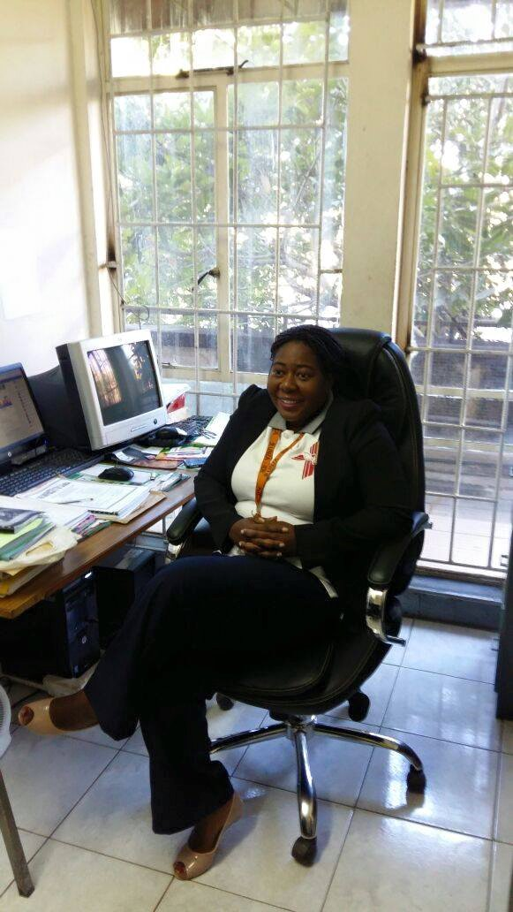

I teach History Teaching Methodology. I joined the UNZA in 2011 as a Staff Development Fellow, and was appointed as a lecturer in 2016. My research interests are in History, History Education, Inclusive Education, Curriculum Studies and Literature.

I have been a Principal Trainer on NAD-Zambia’s Inclusive Education Programme, attending the training of trainers workshops in Livingstone, Southern Province. I have also facilitated inclusive education pre-service training for student teachers at UNZA.

The trainings have helped me to be sensitive to the needs of all students, to embrace all students and to understand that it is possible to teach in an inclusive way. The trainings have also helped me realise that there is hope for every student through the inclusive methodologies to access quality education and equality in society.

I believe that inclusive education is a very pertinent tool in tertiary education because institutions of higher education also receive students from diverse backgrounds such as students from rich families, poor families, refugees, those with special needs and intellectual impairments. These factors come with their own challenges that could affect learners’ achievements. Thus, it is very important for all lecturers from different faculties to be trained to teach inclusively. Teaching in an inclusive manner will provide education that is sustainable and affordable to all students. It can also help students develop skills that are relevant in the 21st century around the globe such as critical thinking, cooperation and independent thinking. Therefore, inclusive education should be provided at all levels of education.

I would like to encourage various stakeholders in society, such as policy-makers, educators, teachers, parents and non-governmental organisation to embrace and support the concept of inclusive education in Zambia.

# Buddies – Observers in Zambia

## Caleb Callan Chabiauni

**Trainer of trainers and a training officer at Response Network Livingstone.**

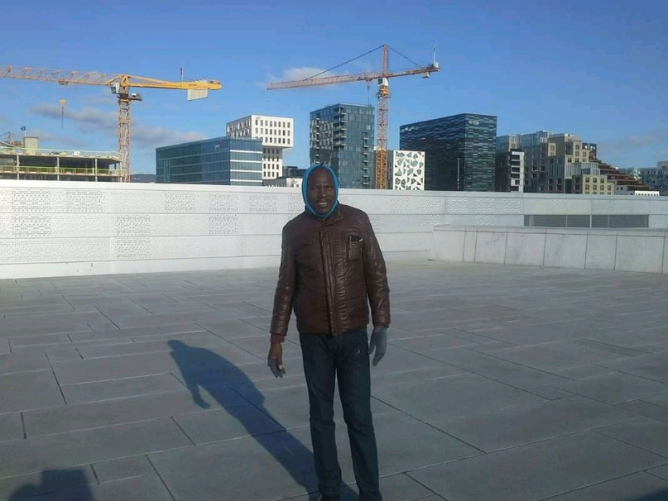Response Network Livingstone is a self-help non-governmental organisation. We believe that all people possess qualities that can enable them to mobilise and improve their living conditions. Instead of pitying people and making them feel that they are poor, we provide optimism and ensure they understand that they are rich in so many ways, and that they can, in fact, solve most of their own problems without depending on any donor. The communities do the work themselves and take sustainable steps forward from poverty towards improved human rights and development.

As an Observer trained by EENET for NAD-Zambia’s inclusive education programme, my main role is to encourage inclusiveness in schools and in communities and to monitor implementation of the inclusive education programme in the six pilot schools, and make recommendations that influence project management and development.

The most exciting part about my role as an Observer is that I interact with different vulnerable groups and stakeholders both from the private sector and Government on issues of disability, inclusion and development. It brings so much fulfilment when I sees how teachers and communities have accepted the integration between special education and inclusive education.

## Jesart Ngulube

**Senior Education Standards Officer (SESO), in-charge of Inclusive and Special Education at the Provincial Education Office (PEO) of Southern Province.**

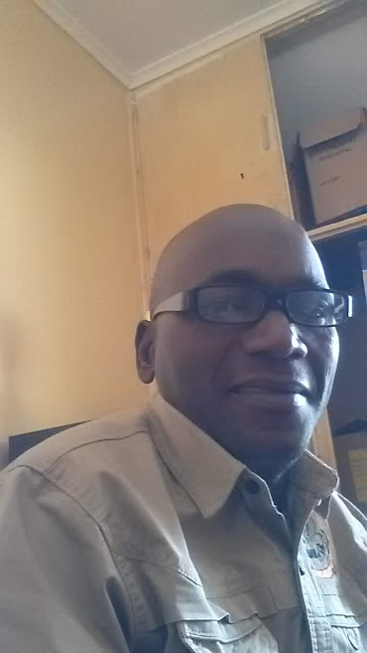

NAD-Zambia is implementing inclusive education in Kazungula, Livingstone and Zimba districts of the province. I am a teacher and formerly a head teacher with extensive experience in special education and inclusion. I became a special educational needs and/or disabilities (SEND) teacher and gained an M.Sc. in Disability Studies. I held several management roles at St. Mulumba special school in Choma District, Southern Province.

I have a hearing impairment and am a regular user of hearing aids and I communicate through speech and sign language. I pride myself in being a highly organised and efficient SESO, with a thorough and precise approach to promoting inclusive education in the province and throughout Zambia. In my current role, I give technical support to the Provincial Education Officer (PEO), the Provincial Education Standards Officer (PESO) and Civil Society Organisations (CSOs) on the education of learners with SEND in the province.

Since 2018, I have been an Observer for NAD-Zambia’s inclusive education programme in Southern Province. From the monitoring of inclusive education in the implementing pilot schools, I have been observed that:

* The concept of inclusive education is understood by most stakeholders from the pilot schools in the three districts.
* Inclusive education is achievable in mainstream classrooms as long as there is a change of mind-set and attitude by all stakeholders, especially teachers who have been teaching learners with SEND in special schools and special units.
* A large number of teachers have been trained in the pilot schools, with support from NAD-Zambia and EENET. For example, they have learned inclusive teaching and learning strategies and creating teaching and learning aids (TLAs) from locally available materials.
* The pilot schools’ infrastructure – classrooms and toilets (with support from NAD-Zambia) – have had ‘facelifts’ to ensure their accessibility by all learners, including those with SEND.
* Learner enrolment, especially of learners with SEND, has increased in the pilot schools. This is an indicator of the success story of the inclusive education programme being implemented in Southern Province.
* School Inclusion Teams (SITs) have been formed in all pilot schools.
* Voluntary school inclusive education coordinators (also known as school IECOs) have been appointed to coordinate inclusive education activities in their schools. They are also involved with their SIT and coordinate collaboration with the community.

## Lillian Haangoma

**District Education Standards Officer (DESO) for Choma, Southern Province.**

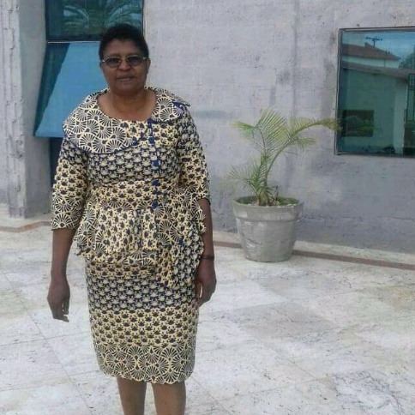My managerial and supervisory roles include the following: administration, inspection and supervision of schools, planning of educational programmes and development, interpretation of policy matters in education under the District Education Board (DEB) office.

I am a trained Observer with EENET and NAD-Zambia’s inclusive education programme. As an Observer, I make sure that the pilot schools and the community which I observes are in line with Zambia’s inclusive education policy guidelines. Among the changes I observe each year during the programme include:

1. General changes in the infrastructure with the schools and the community to make them more accessible to learners with disabilities.
2. Changes in the teaching methods. Teachers have adopted the learner-centred approaches to teaching and learning.
3. There was a change in the attitude (it is now more positive) of the learners and educators and most importantly the community towards including all learners.
4. There was positive collaboration among all stakeholders. The communities, the school system, the DEB office and Ministry of General Education (MoGE). The MoGE allowed the teachers to be trained within their schools during their normal work schedule
5. The increase in overall enrolment of learners with special educational needs after the inclusive education programme was introduced.

These observed outcomes and more are what makes me enjoy my job so much. In addition, I was able to travel to different communities and interact with various stakeholders from local communities, the local government, Disabled People’s Organisations and non-governmental organisations.

## Musola Kaseketi

**Film director.**

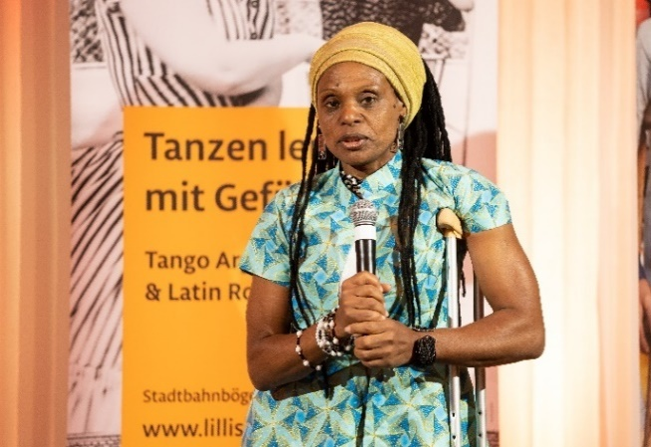I am Zambia’s first female film director. I am ultimately responsible and accountable for the success and smooth running of my company, Vilole Images Productions. These days I delegate a lot of my work, but I oversee the organisation’s specific projects and activities to ensure the desired results are achieved, the most efficient resources are used and the different interests involved are satisfied.

After completing high school, I trained as a Development Activist by Southern Africa Federation of Disabled (SAFOD). I remain a disability and human rights advocate and am passionate about disability advocacy, skills gaining and I continue to embrace people from different circles, sharing whatever I learn with those who cross my path.

As an inclusive education Observer I have learned a lot about the inclusive education programme and this excites me. I have learned:

* The difference between special education and inclusive education. It is uplifting to see how inclusive education promotes parity of esteem and addresses inclusion not only biased to disabilities, but looks beyond disability. It addresses other social challenges different learners experience, which can become hindrances to their learning.
* That involving both teachers and communities allows for a more effective identification of children with disabilities. People know everyone in the community and the saying “everyone is everyone’s child” works well here because there is concern and support not only from the immediate family members. Once the community is sensitised, the community members support each other, with anxious to see the results.
* Inclusive education thrives to protect and promote active and equal participation.
* Children, including those with developmental disabilities, autism and intellectual disabilities, are able to socialise through activities such as community reading groups, while parents of children with physical disabilities received advice on rehabilitation exercises.
* The teaching methodology is active, creative, and collaborative among members of the classroom community.

What do I enjoy the most about being an Observer in NAD-Zambia’s inclusive education programme?

* First and foremost, the sitting arrangement compared to when I was at school is great because you cannot automatically identify a learner with specific needs if you have not been told. Learners are purposely grouped together in differing abilities so they feel part of the class, inspired and participate equally. Those with specific needs are not intimidated. Mostly I see lively and happy learners despite their disability.
* The learners and teachers learning from each other and solving problems together confirm and promote the equalness of the esteem approach.
* One great example is if you enter an inclusive class as an Observer and both the teacher and learners continue using sign language. You will not identify anyone with a hearing impairment unless you are told.

## Mwenya Nicholas Mwamba

**Principal Education Officer-Special Education at the government offices in Lusaka**

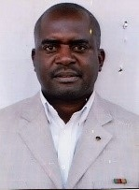I am a teacher and have risen through ranks in the Ministry of General Education (MoGE) to be Principal Education Officer-Special Education at the government offices in Lusaka. The main role I perform is managing and coordinating the provision of inclusive education and special education for pre-school, primary school and secondary school teacher education in order to ensure provision of education to ALL learners, irrespective of their vulnerabilities, including those with special educational needs and/or disability (SEND). This includes, and is not limited to, policy, planning, training, research, management, monitoring and evaluation. I am the MoGE’s focal point person for disability.

I have worked with learners with SEND for 24 years; I am passionate about improving the lives of these learners in Zambia. I like it when I see learners with SEND accessing a quality, relevant and inclusive education; as a government we are striving to reach that standard. In inclusive education there are three pillars, namely Presence, Participation and Achievement (PPA). Anything short of this is not inclusive education. This is a big lesson to me and all who teach learners with SEND. With my involvement in inclusive education I have come to respect diversity and working with all children, young people and adults. I make sure that PPA is achieved though finding solutions to the challenges/barriers all learners face.

I have been a focal point person for NAD-Zambia’s inclusive education programme in the country. I have been involved in giving advice, attending and presenting at the annual inclusive education symposium, and being involved in the MoGE’s curriculum development centre (CDC) approval of the inclusive education teacher training modules, which have been co-created with Zambian educators, including pilot school teachers and the inclusive education programme’s Principal Trainers.

## Samson D Sakala

**District Education Board Secretary (DEBS) for Kazungula District, Southern Province.**

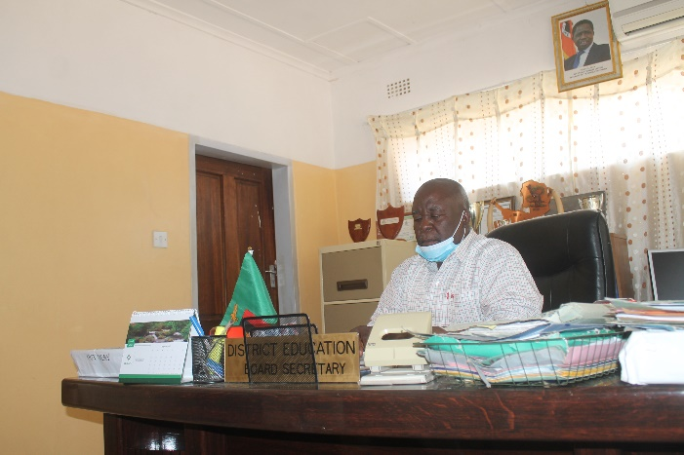

My roles as DEBS are to plan for the development of education; to ensure that standards are maintained in all learning institutions; to manage human resources; and to establish and maintain effective mechanisms for monitoring and evaluation to enhance accountability in the learning and teaching system in the district.

I have been an Observer in CBR Zambia support programme for inclusive education since the onset in 2015/16. Being an Observer has helped my work in so many ways, especially to plan and manage human resources and materials in an inclusive manner. I make sure that the available resources in the district are well distributed according to the specific needs of a particular learning institution. This includes deployment of well trained teachers and educators, ensuring that the learning institutions in the district are accessible to all learners with and without disabilities, and most importantly that there is inclusive development.

During my work as an Observer I collaborated with the Ministry of General Education, the standard officers, CBR and my team mates to ensure no one is left behind on issues of disability, inclusion and education. I was able to report on several positive changes as a result of inclusive education. These include: change of attitude among the teachers and learners; the school environment and the community became disability accessible; and more learners with special needs were included in the schools

What I enjoy the most about my job is to see all learners participate, be present and achieve. To me the most important agenda is to supplement Government policy on education and interact with different communities and partners to promote inclusive education.

## Sharon Handongwe

**Programme Manager at Hospitaller Order of St. John of God, Holy Family Rehabilitation Centre in Monze, Zimba District, Southern Province.**

Over the past 6 years, I have worked on Community Based Rehabilitation/Community Based Inclusive Development (CBR/CBID) with different government departments, international organisations and local organisations, and disabled people’s organisations (DPOs); all offering a vast wealth of experience to the work of the rehabilitation centre.

I have worked closely with NAD-Zambia’s Livingstone office on the Inclusive Education Programme as an Observer, annually monitoring the improvements in the pilot schools. Being an Observer has offered me a safe learning space to share experiences and progressively learn from all stakeholders; each one bringing to the programme their most valued expertise. Seeing the positive gains of the programme has made me decide to influence my institution to have an inclusive learning school.

I enjoy field work and I am a hands-on person that wants to see results. A smile from a child, the happiness on a parent’s face at the smallest achievements shown by the child and the desire to continue the programme by the parents/guardians and all stakeholders drives me to give my whole in CBR/CBID implementation.

## Tom Lwendo Mungala

**District Community Development Officer, Kazungula District in Zambia.**

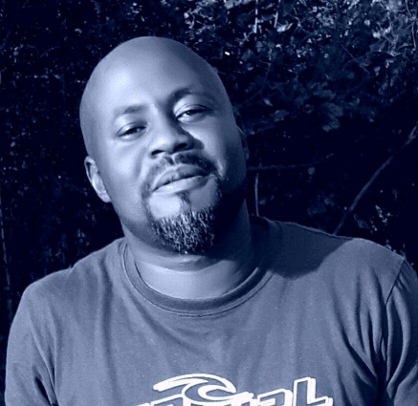My role is to implement Government policy on community development and to monitor day-to-day community engagements at district level.

I am a trained Observer for the Inclusive Education Programme of NAD-Zambia (CBR/CBID). As an Observer, I realised the importance of collaboration, monitoring and communication if the expected outcome must be achieved both for the programme and also as an individual.

The Inclusive Education Programme has taught me the importance of following up programmes to ensure that all the stages are implemented in an effective way, and I have also adopted this in my job as Community Development Officer.

What I enjoy most about my job, both as an Observer and as a Community Development Officer, is the interaction with different communities, groups and stakeholders, which include the vulnerable people, people with disabilities, and the aged, and being able to contribute positively towards inclusive education and community development. Inclusive education has impacted greatly on my work as it has the monitoring and evaluation component and an inclusive approach.

## Winniefreda (‘Winnie’) Moonga Bbwantu

**Community-based Rehabilitation (CBR) Coordinator and Public Health Nurse for Livingstone District Health Office, Southern Province.**

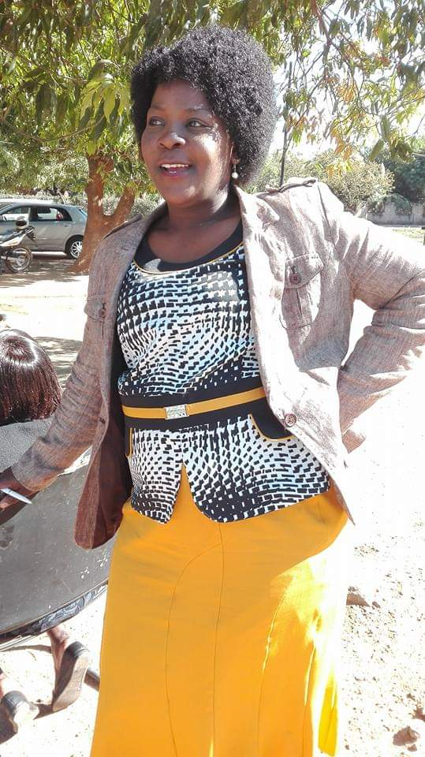Over the past 10 years I have worked with different non-governmental organisations (NGOs), government departments, communities and disabled people’s organisations (DPOs). My role is to coordinate programmes concerning persons with disabilities at community and district level, so that they are also included in all health programmes hence not leaving them behind. This includes planning, implementation, monitoring and evaluating the programme to ensure that the persons with disabilities are included.

I have worked closely with NAD-Zambia at the Livingstone office. I have trained a lot of community-based volunteers in various communities including Kazungula, Livingstone and Zimba districts. I trained as an Observer for the Inclusive Education Programme. I have carried out the annual monitoring in the pilot schools, checking on improvements to the schools and the challenges that schools were facing during the programme implementation. The findings were shared among the Observers, Principle Trainers and NAD-Zambia staff.

Being an Observer has helped me understand that there was no need to have special schools for children with disabilities. Instead, the community schools should modify and become inclusive. This can also be done by making the schools accessible and training the school teachers so that they accept every child and do not leave anyone behind.

I loves my job; it helps me understand the needs of persons with disabilities and therefore I can understand how to include everyone in my day-to-day activities and be able to have better relationships with them. I enjoy working with the community because it helps me understand the community structures, and hence helps me to implement the desired outcomes of CBR/CBID. It also gives me pleasure working with marginalised people; giving them help and giving them hope.